**Migration of SQL Server 2008 Databases (IIS Web App Backend Databases) from On-Premises to Cloud Environment (Azure) using Web Deploy**

**Prerequisites 1 –**

1. **Web Deploy Installation on Source and Target Servers**

* Web Deploy (msdeploy) simplifies deployment of Web applications and Web sites to IIS servers. Administrators can use Web Deploy to synchronize IIS servers or to migrate to newer versions of IIS.
* Web Deploy Tool also enables administrators and delegated users to use IIS Manager to deploy ASP.NET and PHP applications to an IIS server.
* ***Web Deploy enables you to package your Web application content, configuration, databases and any other artifacts like registry, GAC assemblies etc., which can be used for storage or redeployment.***
* Once created, these packages can be deployed using Web Deploy cmdline or IIS Manager without requiring administrative privileges.
  1. **Web Deploy Installation**

We can install Web Deploy by using the Web Platform Installer (Web PI) or the Web Deploy MSI.

* Use the Web Platform Installer (Web PI) to install the Recommended Server Configuration for Web Hosting Providers, which includes Web Deploy
* Use Web PI to install Web Deploy separately (with or without its dependencies)
* Use the Web Deploy installer.

The Recommended Server Configuration for Web Hosting Providers can be installed on Windows 2012 Server or later. For information about installing on earlier versions of Windows Server with IIS 7, see [Installing and Configuring Web Deploy on IIS 7](https://docs.microsoft.com/en-us/iis/install/installing-publishing-technologies/installing-and-configuring-web-deploy).

1. Download the [Web Platform Installer](https://www.microsoft.com/web/downloads/platform.aspx).
2. Open Web PI.
3. In Web PI, click in the search bar in the upper-right hand corner, enter "Recommended" in **Search**, and press **Enter**.
4. Select **Recommended Server Configuration for Web Hosting Providers**, and then click **Add**.

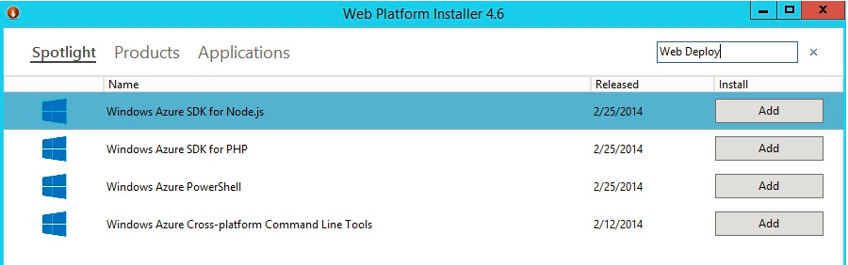

1. Select the Web Deploy that you want, and then click **Add**.

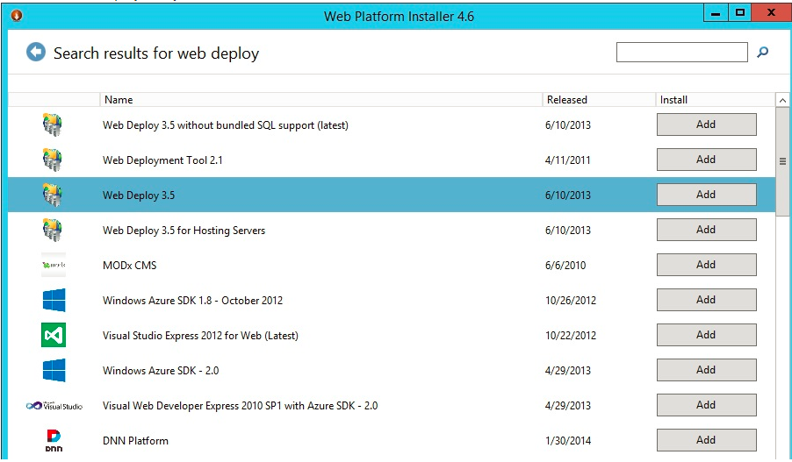

1. On the **Prerequisites** page, click **I accept**.
2. After the installation has completed, click **Finish**.

**Note – Web Deploy should be installed on both Source and Target Servers from where the data is to be migrated.**

**Prerequisites 2 -**

Web Deploy dbFullSql Provider

**dbFullSql:**

* The **dbFullSql** provider ***enables first-time publishing of databases from a local SQL Server development database to a remotely hosted SQL Server database.***
* The **dbFullSql** provider is useful if you are a developer who hosts your Web application databases on remote machines that are serviced by hosting providers or enterprise IT groups. Although you must have administrative privileges on your local development SQL Server, you do not necessarily have to have administrative privileges on the remote SQL Server.
* Before running the **dbFullSql** provider, you should have completed your testing in a development environment and be confident that application will work as expected.
* The **dbFullSql** provider uses SQL Server Management Objects (SMO) to reverse engineer the source database into Transact-SQL DDL (Data Definition Language) and DML (Data Manipulation Language) scripts.
* You can review these scripts before running them on the target server. After the script is executed on the target database, a report of the actions applied to the target database is returned in XML format.

The **dbFullSql** provider requires the following components, which must be installed manually.

* SQL Server Management Objects (SMO) v. 10.
* Microsoft Core XML Services (MSXML) 6.0
* Microsoft SQL Server 2008 Native Client (SQL Native Client)

Descriptions and download locations for these components follows.

**SQL Server Management Objects (SMO) v. 10. (SMO) Installation**

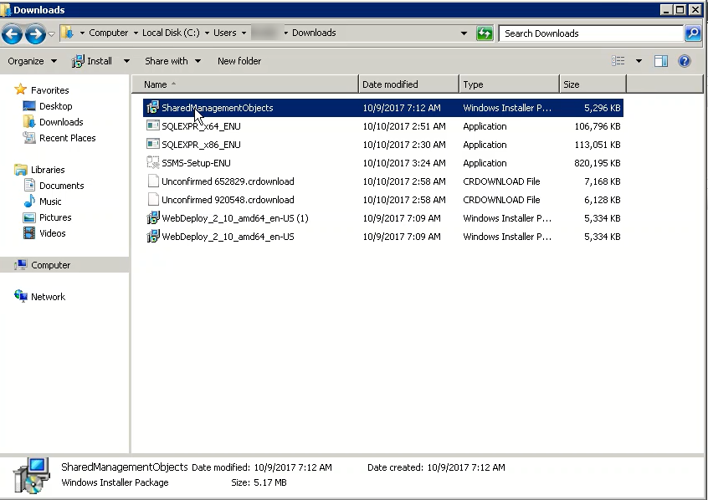

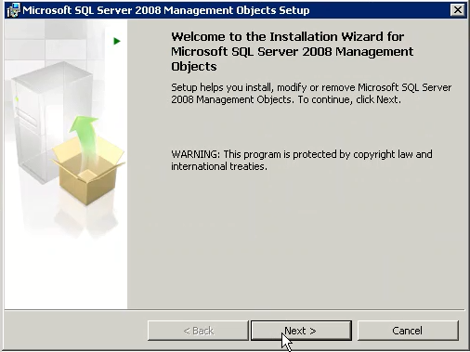

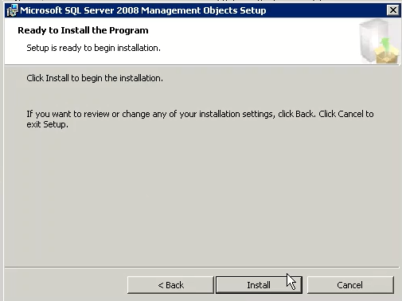

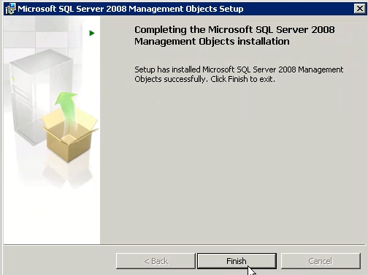

* Microsoft Core XML Services (MSXML) 6.0 Installation

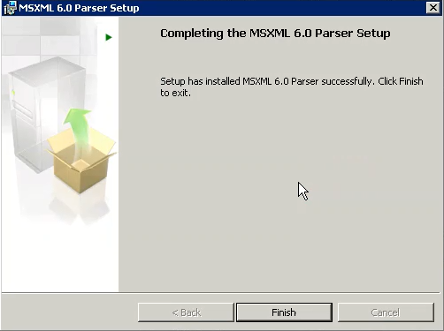

* Microsoft SQL Server 2008 Native Client (SQL Native Client) Installation

Installation of SQL Server Native Client will be

Migration using Web Deploy

Web Deploy Command Line

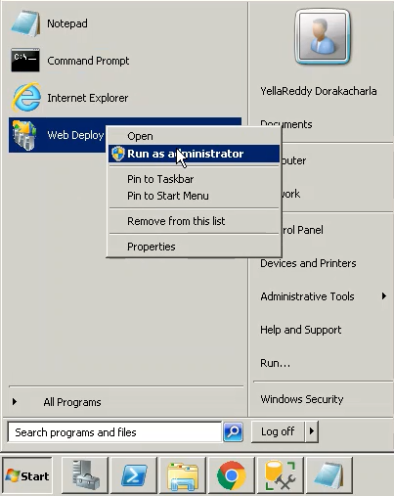

**Method 1 -**

* 1. Export the database to an Archive file using Web Deploy and then import it on the destination server with Web deploy.

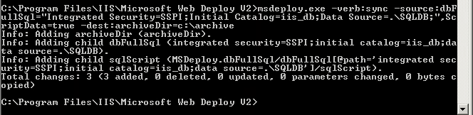

* 1. Locate the Archive file where it is stored and Copy the above Database Archive file to destination Server where we going to migrate our Databases.

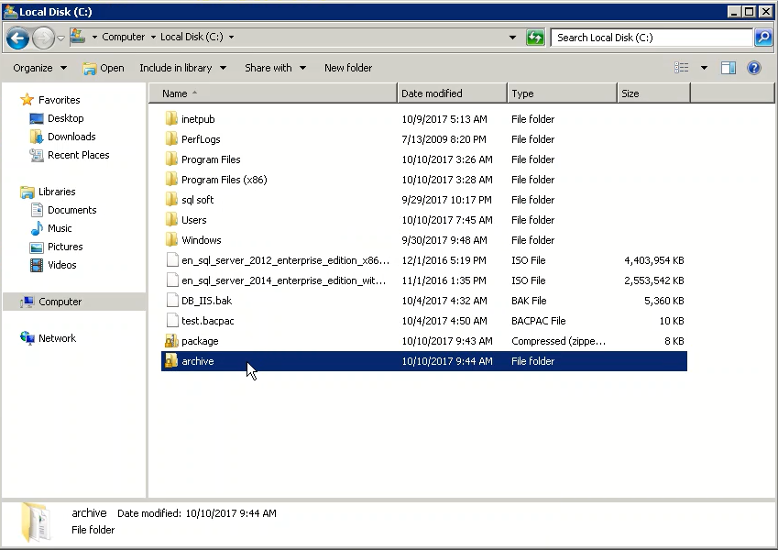

Create an empty DB in the destination SQL Server.

Web Deploy Command to restore DB from archive Files.

**Note: The command should run in Destination Server Side**

***msdeploy -verb:sync -source:archive dir=c:\archive -dest:dbFullSql="Data Source=.\;Initial Catalog=iisdb;Integrated Security=SSPI***

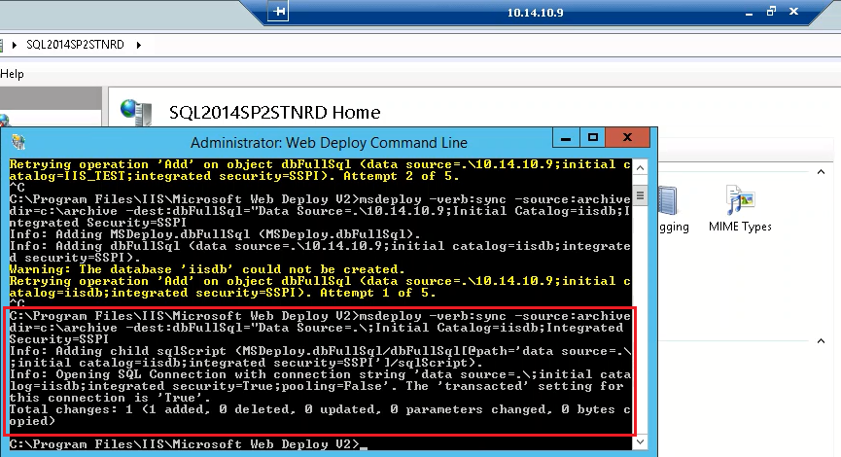

***Validation***

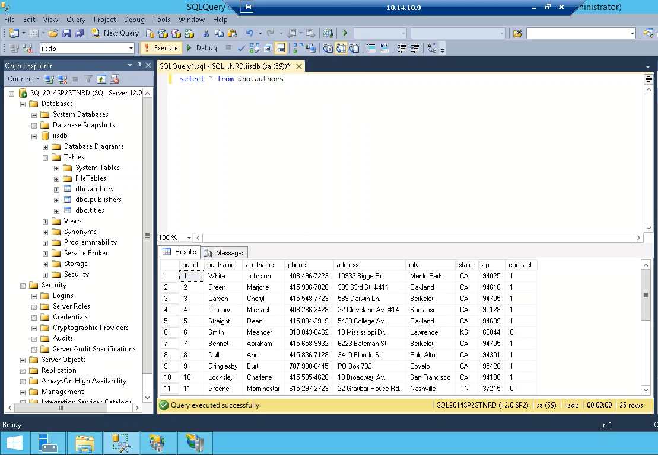

**Method 2 – Migration using Web Deploy Sync using dbFullSql directly on Destination Servers**

**Note – This method worked on only On-Prem to On-Prem**

**Create an Empty DB at Destination Server**

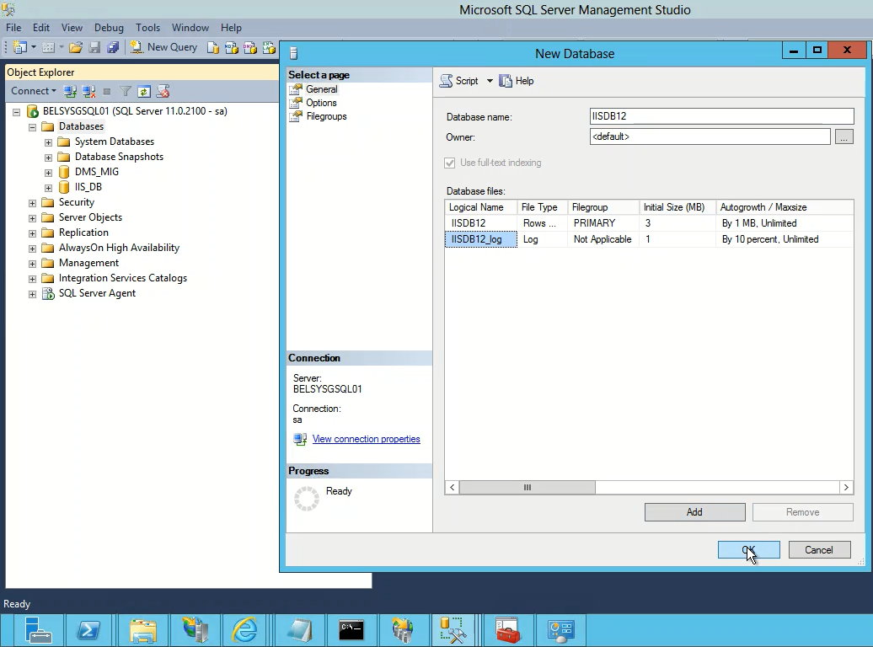

**Web Deploy Command**

Command executed at Destination Server 10.1.10.24 (SQL 2012) – Using the Source Server as 10.1.10.101 (SQL 2008)

***msdeploy.exe -verb:sync -source:dbFullSql="Data Source=10.1.10.101\SQLDB;Initial Catalog=iis_db;Integrated Security=SSPI" -dest:dbFullSql="Data Source=.\;Initial Catalog=IISDB12;Integrated Security=SSPI" -Verbose***

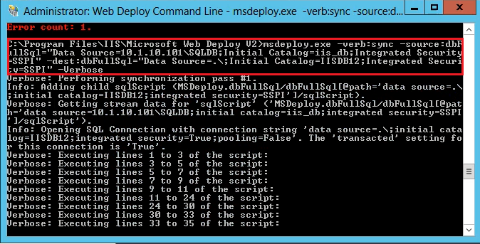

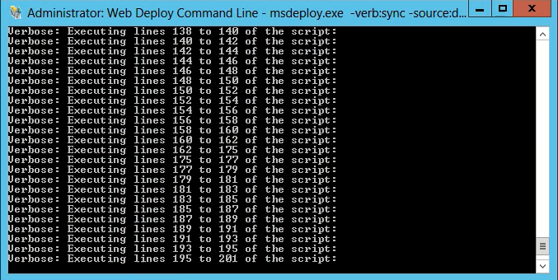

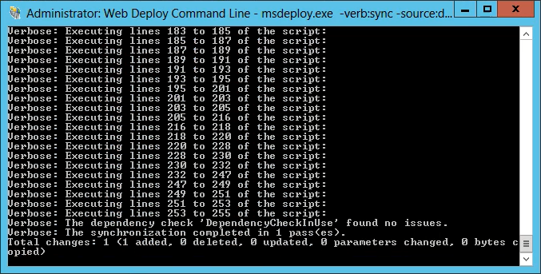

**Validation**

